Phishing Email Investigation
Author: Farhan Khan
Role: SOC Analyst (Aspiring)
Date: 24 February 2026
Severity Level: High

## Executive Summary

A phishing email impersonating a financial service provider was analyzed.
The email contained a malicious URL designed to harvest credentials.
Header analysis revealed SPF failure and IP mismatch.
The embedded URL was flagged by multiple security vendors.
Immediate blocking and user awareness training were recommended.

## Incident Overview

- Attack Type: Phishing
- Target: Email User
- Delivery Method: Email
- Objective: Credential Harvesting
- Initial Detection: Suspicious sender domain

- Sender IP: 89.144.44.2
- SPF Result: Fail
- DKIM: Not aligned
- Return-Path mismatch detected

### Indicators of Compromise

IP Address: 89.144.44.2
Malicious Domain: DB8EUR06FT032.mail.protection.outlook.com
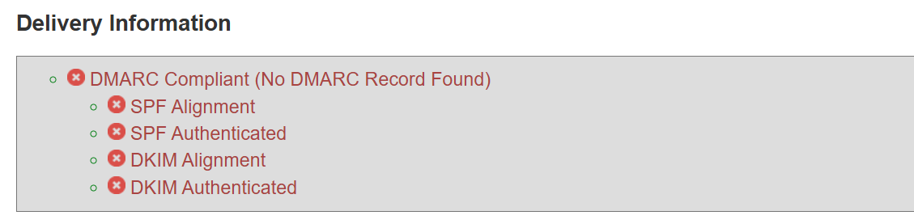
*Sender details with IP Address

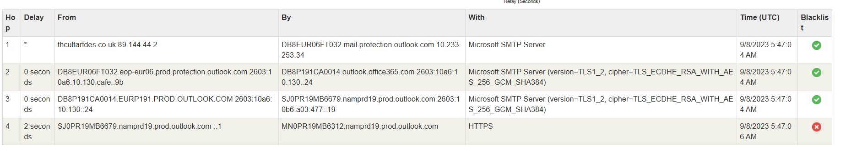

*Email Header Information

